
El-Sewedy University of Technology

Faculty of Engineering Technology

Department of Computer engineering technology

Graduation Project II

Pre-training of Deep Bidirectional Transformers for Language Understanding

Prepared By:

Student Name XXXX ID XXXXX

Supervised by:
Dr.
2024/2025

Acknowledgement

Abstract

Contents
Chapter 1: Introduction 7
1.1 Problem Statement 9
1.2 Motivation and Justification 9
1.2.1 Example of a subpoint 9
1.2.2 Example of a subpoint 9
1.2.2.1 Example of a sub subpoint 9
1.3 Vision 10
1.4 Mission 11
1.5 SWOT Analysis 12
1.6 Project Outcome 13
1.7 Document Organization 14
Chapter2: Feasibility Study 15
2.1 Hardware Technology 15
Chapter3: Selection 16
3.1 Hardware Technology 16
3.2 Software Technology 16
3.3 CODE 16
Chapter 4: Methodology 17
4.1 System Block Diagram 17
4.2 Flow Chart of System 17
4.3 wiring diagram of System 17
Chapter 5: System Implementation 18
5.1 Part One 18
5.2 Part two 18
5.3 Part three 18
5.n Part n 18
Chapter 6: Conclusion 19
APPENDIX A 20
APPENDIX B 21
References 22

List of figures
Figure 1 Example of listing figure ------------------------------------------------------------------------------12
List of Abbreviations

Abbreviations | Definitions
SUT | El-Sewedy University of Technology

Pre-training of Deep Bidirectional Transformers for Language Understanding

Chapter 1: Introduction



Chapter 1: Introduction

1.1 Problem Statement

1.2 Motivation and Justification

1.2.1 Example of a subpoint

1.2.2 Example of a subpoint

1.2.2.1 Example of a sub subpoint

1.3 Vision

1.4 Mission

1.5 SWOT Analysis

1.6 Project Outcome
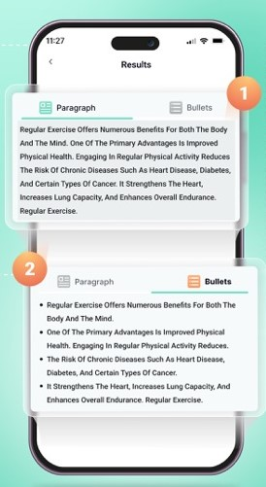

Figure 1 Example of listing figure

1.7 Document Organization

Chapter2: Feasibility Study

2.1 Hardware Technology

Chapter3: Selection

3.1 Hardware Technology

3.2 Software Technology

3.3 CODE

Chapter 4: Methodology

System Block Diagram

Flow Chart of System

wiring diagram of System

Chapter 5: System Implementation

5.1 Part One

5.2 Part two

5.3 Part three

5.n Part n

Chapter 6: Conclusion

APPENDIX A
Code

APPENDIX B
Sign 1

References

